**Masconomet’s Fee-Based Athletics Program**

Why are students charged a fee to participate in Masco athletics? Why do the fees differ from sport to sport? What if a student’s family cannot afford the fee to participate in a sport?

The athletics program at Masconomet Regional High School plays an integral part in school culture. Students have the opportunity to participate in a myriad of activities that will enhance their educational experience. The sports program is committed to the physical, emotional, social, and mental development of all who participate. To be eligible to participate in athletics at Masconomet Regional High School, students must meet the academic requirements of the Massachusetts Interscholastic Athletic Association (MIAA) as well as Masconomet High School’s standards for academics and student conduct.

Masconomet offers a comprehensive program that includes 27 boys’ and girls’ teams at varsity and sub-varsity levels. 764 High School students participated in athletics during the 2015-2016 school year.

The large majority of Massachusetts high school athletics programs are partially fee-based in a similar fashion to Masco. When school budgets became chronically underfunded beginning in the year 2000, many school districts faced the choice of cutting athletics programs to preserve academic programs, or going to a fee-based program.

Thirteen years ago, during the severe Tri-Town budget crisis of 2003, the School Committee decided to prioritize academics over athletics. At that time, rather than utilizing a larger portion of the local tax revenue for non-academic activities, they decided that athletics should be funded partially through user fees. It was decided that fees should be charged to cover approximately 60% of the cost. During the annual budget process, the School Committee reviews the actual costs of each sport and determines if the fees are meeting the 60% benchmark. If a sport’s fee falls below 55% of the cost , they look at raising the fee to put it within an acceptable range.

The process and financial documentation used to determine the fees is a bit complicated, but worth explaining. A detailed spreadsheet (available on the Masconomet website) details the expenses that are attributed to each sport. Expenses are broken into two categories. Direct expenses are those such as coaches, officials, transportation and special equipment that correspond directly to a sport. Indirect expenses are items such as the athletic director, facilities manager and league membership that are considered overhead. These overhead expenses are totaled and allocated to each sport based on the anticipated number of players. Uniforms, for example, are in overhead to even out the expense per sport over the years. Since new uniforms are not purchased for each sport each year, rather than having one year with a high expense, including it in overhead means each sport is contributing to their uniforms on an even basis.

Direct expenses and the appropriate percentage of indirect expense are totaled to determine the total cost to run each sport. This total cost is divided by average student participation to determine the cost per student. The user fee for each sport is then set based on fee ranges that approximate 60% of the cost per student.

It should be noted that Masconomet’s Athletic Director position is 60% of full-time. The other 40% of the combined position oversees and evaluates the wellness staff and curriculum grades 7-12. Masco is the only large school in the area with a part-time Athletic Director.

A few sports such as Football, Basketball (Boys and Girls) and Wrestling charge admission for home competitions. Funds received through admission tickets, which were approximately $40,000 last year, are pooled and used to provide scholarships for those families who cannot afford the user fee for their son or daughter. Families may apply for these scholarships by completing an application process publicized each season.

Masconomet has a proud athletics history and our teams and student-athletes always represent Masco’s values of excellence and sportsmanship. Masco athletic and co-curricular activities cost nearly $1.1million to run in the last academic year.. Participation fees continue to support a broad offering of sports and a high quality experience for our students in a manner that is cost effective to the Tri-Town Community.

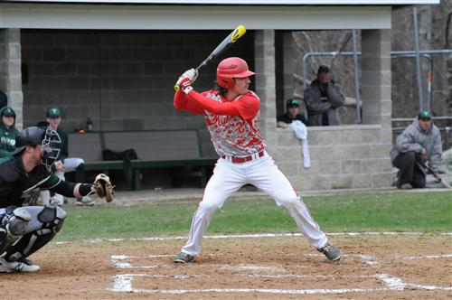

**ELIAS VARINOS (pictured above) was recently named to the Boston Globe All-Scholastic Baseball Team.**

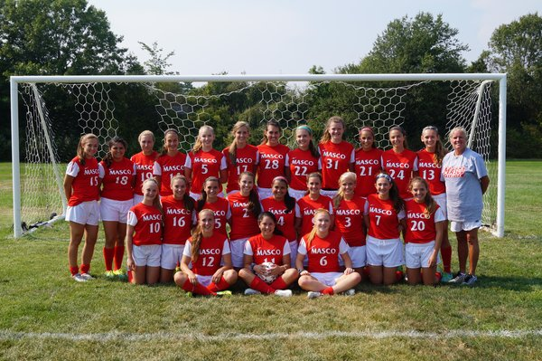**Girls Soccer CAL Champs 2015**



Girls’ Volleyball Team 2016



Boys Soccer Divisin II North Champs 2015

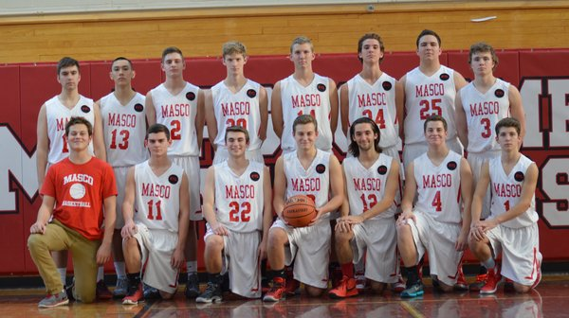Boys Basketball 2015-2016

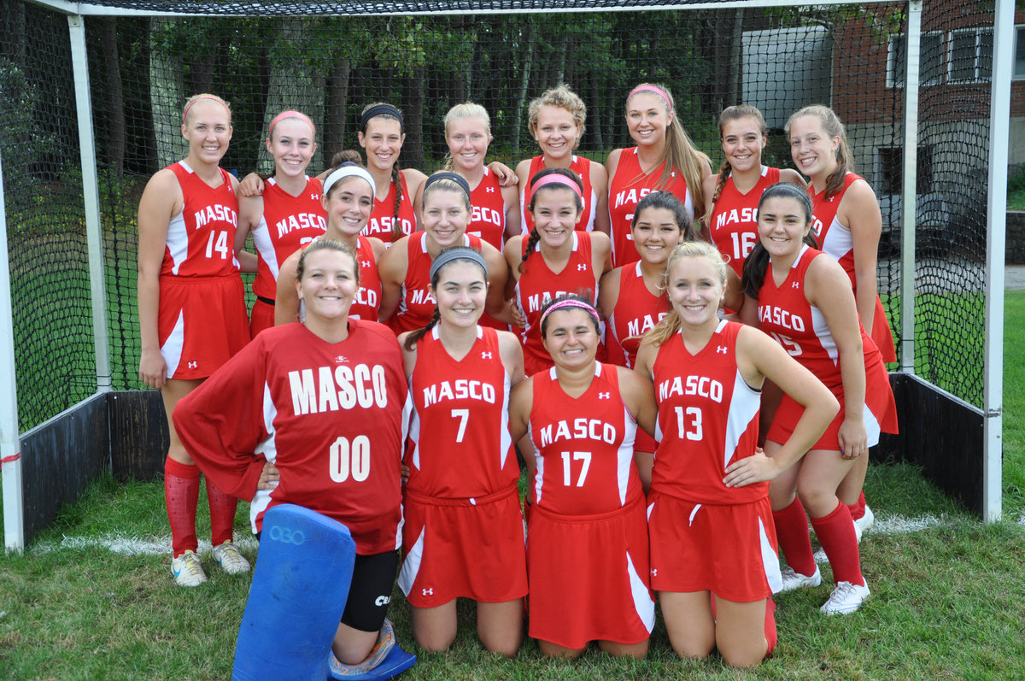

Field Hockey 2015-2016